Enhancing Multiclass Potato Leaf Disease Classification Through CNN–Vision Transformer Ensemble Learning

Md. Zihad Hossen
Southeast University
Dhaka, Bangladesh
2023100000098@seu.edu.bd

Anika Firose
Southeast University
Dhaka, Bangladesh
2023100000445@seu.edu.bd

Mehedi Ahamed
Southeast University
Dhaka, Bangladesh
abcd@seu.edu.bd
Fatima Jannat Abonty
Southeast University
Dhaka, Bangladesh
2023100000348@seu.edu.bd

Abstract— Accurate identification of potato leaf diseases under uncontrolled environmental conditions remains challenging due to variations in leaf appearance, complex visual patterns, and class imbalance. This paper presents a comparative deep learning framework integrating Convolutional Neural Networks (CNNs), a Vision Transformer (ViT), and soft-voting ensemble techniques for automated potato leaf disease classification. The study utilizes a dataset containing 3,076 images across seven classes, divided into training, validation, and testing sets using a duplicate-aware splitting strategy. Three pretrained CNN architectures, DenseNet121, ResNet50, and EfficientNetV2B0, including variants with Squeeze-and-Excitation (SE) attention and focal loss, were evaluated against a partially fine-tuned ViT-Base model. The CNN models were trained for 50 epochs, while ViT underwent 30 epochs of training. Experimental results demonstrate that ViT achieved the highest individual-model test accuracy of 84.78%, with a macro-F1 score of 82.28% and macro ROC-AUC of 98.15%. Furthermore, the proposed ViT–ResNet50 soft-voting ensemble achieved 86.09% test accuracy and 84.40% macro-F1. Incorporating EfficientNetV2B0-SE into a three-model ensemble further improved macro-F1 to 84.95%, while maintaining 86.09% accuracy. These findings indicate that combining transformer-based global representations with CNN-based feature extraction can enhance multiclass potato leaf disease classification. However, further evaluation across independent datasets is necessary to establish generalization under real-world agricultural conditions.
Keywords— Potato leaf disease classification, deep learning, Vision Transformer (ViT), convolutional neural networks (CNNs), EfficientNetV2B0, ensemble learning, precision agriculture.

Introduction
Potato (Solanum tuberosum L.) is an important agricultural crop contributing to global food production and food security. However, leaf diseases significantly affect its quality and productivity. Early and accurate disease detection is essential for effective crop management. Traditional diagnosis relies on manual inspection, which is time-consuming, subjective, and challenging for large-scale agricultural applications. Consequently, deep learning-based automated disease detection has emerged as a promising alternative [1]. Despite recent advancements, multiclass plant disease classification remains challenging due to variations in disease symptoms, leaf textures, illumination, and image backgrounds [2]. Furthermore, the performance of deep learning models varies with architectural design and experimental conditions [3]. These limitations highlight the need for robust feature extraction and classification strategies. Convolutional Neural Networks (CNNs) effectively extract hierarchical image features, while advanced architectures such as EfficientNetV2 improve representation learning and computational efficiency [4]. In contrast, Vision Transformers (ViTs) utilize self-attention to capture broader spatial relationships [5]. Their complementary capabilities motivate CNN–Transformer integration for disease recognition. Although hybrid approaches have shown promising performance in crop disease classification [6], the effectiveness of specific ensemble configurations requires further investigation. Additionally, focal loss offers a strategy for emphasizing difficult training examples [7]. This study investigates a deep learning framework for seven-class potato leaf disease classification using ResNet50, DenseNet121, EfficientNetV2B0, and Vision Transformer architectures. Squeeze-and-Excitation (SE) attention, class-balanced focal loss, and probability-based soft-voting ensembles are explored to improve classification performance. Model effectiveness is assessed using accuracy, precision, recall, Macro-F1-score, multiclass ROC-AUC, and class-wise analysis. In this study, our contributions are as follows:
- A comparative deep learning framework is developed using ResNet50, DenseNet121, EfficientNetV2B0, and Vision Transformer architectures for seven-class potato leaf disease classification. The framework examines complementary CNN–Transformer representations, SE attention, and class-balanced focal loss through controlled architectural ablations.
- Two heterogeneous ensemble configurations, Top-2 (ViT–ResNet50) and Top-3 (ViT–ResNet50–EfficientNetV2B0 with SE attention), are developed using validation-ranked models and equal-weight probability-based soft voting. A duplicate-aware group-based data split is employed, and classification performance is evaluated using multiple metrics, including Macro-F1-score and multiclass ROC-AUC.
- The Top-3 ensemble achieved the highest observed test Macro-F1-score of 84.95% and an accuracy of 86.09% on 460 held-out test images. Compared with the standalone ViT baseline (84.78% accuracy and 82.28% Macro-F1-score), the ensemble improved accuracy by 1.31 percentage points and Macro-F1-score by 2.67 percentage points. These findings suggest the potential of heterogeneous soft-voting ensembles for improving multiclass potato leaf disease classification under the evaluated experimental setting.

Literature Review
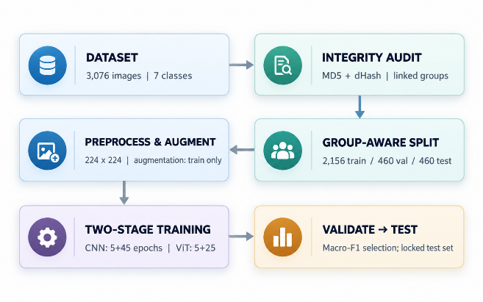
Recent advancements in deep learning have significantly improved automated potato leaf disease classification. However, variations in disease symptoms, illumination, and complex backgrounds continue to challenge model performance. Shabrina et al. [8] evaluated five deep learning architectures using 3,076 potato leaf images across seven categories. EfficientNetV2B3 achieved 73.63% test accuracy, demonstrating the difficulties of classification under uncontrolled environmental conditions. However, their evaluation primarily focused on individual CNN architectures without investigating heterogeneous ensemble strategies. Boukhlifa and Chibani [9] proposed DSCSkipNet, a lightweight CNN integrating depthwise-separable convolutions, skip connections, and pointwise convolutions. The model achieved 80.45% average test accuracy using four-fold cross-validation. Although computationally efficient, the approach relied on convolutional representations without incorporating transformer-based predictions or ensemble learning. Mhala et al. [10] investigated DenseNet201, ResNet152V2, and NasNetMobile using transfer learning, augmentation, and regularization. DenseNet201 achieved 81.31% average accuracy through k-fold cross-validation. Despite addressing model optimization and class imbalance, the study did not explore heterogeneous CNN–Transformer ensembles or probability-based soft voting. Tariq et al. [11] developed RCA-Net, combining residual convolution, attention mechanisms, and multiscale feature extraction for plant disease recognition under complex backgrounds. Their model achieved 78.14% accuracy on potato leaf classification. Although attention mechanisms enhanced feature representation, validation-ranked CNN–Transformer ensemble configurations were not investigated. Sinamenye et al. [12] introduced a hybrid EfficientNetV2B3–Vision Transformer architecture, achieving 85.06% test accuracy. Their findings demonstrated the potential of integrating convolutional and transformer features. However, the study did not evaluate multiple validation-ranked soft-voting ensembles incorporating Squeeze-and-Excitation (SE) attention and class-balanced focal loss. Elkholy et al. [13] proposed a multiscale feature extraction network incorporating depthwise convolutions, pixel-aware weighting, and image enhancement. Their approach achieved 84.30% accuracy on a seven-class potato leaf dataset. Nevertheless, heterogeneous CNN–Transformer probability-based ensemble configurations were not explored. Collectively, these studies highlight the effectiveness of CNNs, attention mechanisms, and hybrid architectures while identifying opportunities for further investigation of ensemble strategies. Accordingly, this study combines controlled architectural ablations, SE attention, class-balanced focal loss, duplicate-aware group-based splitting, and validation-ranked heterogeneous soft voting within a unified seven-class classification framework. The proposed Top-3 ensemble achieved 86.09% accuracy and 84.95% Macro-F1-score on 460 held-out test images. However, differences in experimental protocols and dataset configurations should be considered when interpreting cross-study performance comparisons.

Methodology

Research Design and Overall Workflow
Seven-class potato leaf images are classified using pretrained CNNs, EfficientNetV2B0 attention/loss ablations, ViT-Base, and soft-voting ensembles. Fig. 1 summarizes image integrity checks, near-duplicate-safe partitioning, model training, validation-only selection, and reserved testing.

Fig. 1. End-to-end leakage-aware training and evaluation framework.

Dataset Description, Integrity Checks, and Partitioning
The dataset [14] contains 3,076 RGB images in seven classes: Bacteria, Fungi, Healthy, Nematode, Pest, Phytopthora, and Virus. Original label spelling is retained; inputs are resized to 224 × 224 pixels.
MD5 and 64-bit dHash (Hamming distance ≤ 4) screened duplicate leakage. The audit flagged 55 exact-duplicate groups, 93 near-duplicate pairs, and six possible label conflicts. Connected groups were kept within one partition using StratifiedGroupKFold (seed 42). Table I reports the resulting train/validation/test class distribution (2,156/460/460); conflicting labels await manual review.
TABLE I
GROUP-AWARE DATASET PARTITION BY CLASS
Class | Train | Val. | Test | Total
Bacteria | 400 | 84 | 85 | 569
Fungi | 528 | 109 | 111 | 748
Healthy | 145 | 29 | 27 | 201
Nematode | 43 | 14 | 11 | 68
Pest | 423 | 94 | 94 | 611
Phytopthora | 247 | 47 | 53 | 347
Virus | 370 | 83 | 79 | 532
Total | 2156 | 460 | 460 | 3076

Image Preprocessing and Data Augmentation
CNNs use TensorFlow/Keras pipelines with caching, batch size 32, prefetching, and backbone-specific preprocessing. Training-only augmentation includes flips, rotations, zoom, translations, brightness shifts, and contrast adjustment; evaluation transforms remain deterministic. ViT uses PyTorch/Hugging Face processing, 224 × 224 input, batch size 16, training-only flips, rotations, and color jitter, followed by pretrained image-processor normalization.

CNN Baselines, Channel Attention, and Class-Balanced Objectives
ImageNet-pretrained DenseNet121 [15], ResNet50 [16], and EfficientNetV2B0 feed global-average pooling, 0.30 dropout, a 128-unit ReLU layer, and seven-way softmax. Optional squeeze-and-excitation (SE) attention [17] recalibrates EfficientNetV2B0 channels.
For a feature tensor with H × W spatial locations and K channels, channel pooling is
$$z_{c}=\frac{1}{HW}\sum_{i=1}^{H}{\sum_{j=1}^{W}{F_{ijc}}}$$ | (1)
A ReLU–sigmoid bottleneck provides channel gates and recalibrated features:
$$s=σ\left(W_{2} δ\left(W_{1}z\right)\right), {\tilde{F}}_{ijc}=s_{c}F_{ijc}$$ | (2)
The SE bottleneck has max(⌊K/16⌋, 8) units. Training-only inverse-frequency class weights are
$$w_{c}=\frac{N_{tr}}{C n_{c}}, C=7$$ | (3)
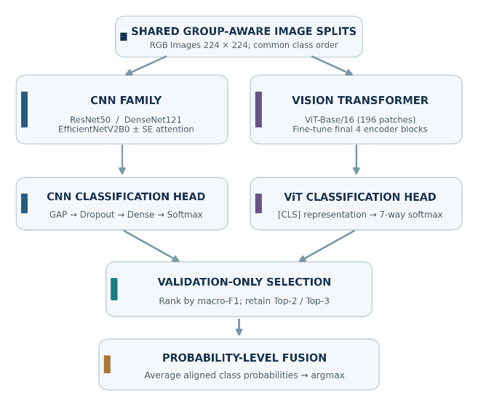
where n_c counts training samples in class c. Alongside weighted and ordinary cross-entropy, the focal-loss configuration uses
$$L_{focal}=-α_{y}{\left(1-p_{y}\right)}^{γ}log\left(p_{y}\right), γ=2$$ | (4)
Here p_{y} denotes the target probability, α_{y} the normalized class weight, and γ = 2; focal training avoids additional class weighting. Table II distinguishes the baseline CNNs and isolated SE, focal, and combined EfficientNetV2B0 ablations.
TABLE II
CNN BASELINES AND EFFICIENTNETV2B0 ABLATIONS
Model / run |  | SE | Loss | Role
DenseNet121 |  | No | WCE | CNN baseline
ResNet50 |  | No | WCE | CNN baseline
EffNetV2B0 A (vanilla) |  | No | WCE | Ablation reference
EffNetV2B0 B (+SE) |  | Yes | WCE | Attention alone
EffNetV2B0 C (+focal) |  | No | Focal | Focal alone
EffNetV2B0 D (SE+focal) |  | Yes | Focal | Combined
EffNetV2B0 (plain CE) |  | No | CE | Loss control

Vision Transformer and Two-Stage Fine-Tuning
ViT-Base/16 (google/vit-base-patch16-224-in21k) receives 196 patches per 224 × 224 image and a seven-class head. Its first five epochs train only the head; the next 25 fine-tune the final four encoder blocks, final layer norm, and head. Validation macro-F1 selects checkpoints.
Patch projections, a class token, and positional embeddings form the input sequence:
$$Z_{0}=\left[x_{cls};X_{p}E\right]+E_{pos}$$ | (5)
Scaled dot-product attention is defined by
$$Attn\left(Q,K,V\right)=softmax\left(\frac{QK^{⊤}}{\sqrt{d_{k}}}\right)V$$ | (6)
CNN training uses five frozen-backbone epochs and 45 epochs fine-tuning the last 30 backbone layers; checkpoints minimize validation loss. Table III reports the respective CNN/ViT optimization schedules, learning rates, batch sizes, and checkpoint criteria.
TABLE III
TRAINING CONFIGURATION FOR CNN AND ViT
Setting | CNN models | ViT-Base/16
Input / batch | 224×224 / 32 | 224×224 / 16
Framework | TensorFlow / Keras | PyTorch / HF
Frozen stage | 5 epochs | 5 epochs
Stage-1 optimizer / LR | Adam / 1×10⁻³ | AdamW / 2×10⁻⁴
Fine-tune stage | 45 ep.; last 30 layers | 25 ep.; last 4 blocks + LN
Stage-2 LR | Adam / 1×10⁻⁵ | AdamW / 2×10⁻⁵ backbone; 2×10⁻⁴ head
Checkpoint | Minimum val. loss | Maximum val. macro-F1
Random seed | 42 | 42

Validation-Driven Model Ranking and Soft-Voting Fusion
Candidates are ranked by validation macro-F1 with identical class order. Fig. 2 shows the CNN/ViT branches, validation-based Top-2/Top-3 selection, and fusion of class probabilities. Recorded validation ranking identifies ViT and ResNet50 as Top-2, plus EfficientNetV2B0+SE as Top-3; this ranking requires confirmation in a clean rerun.

Fig. 2. Proposed validation-guided CNN–ViT ensemble with class-aligned probability fusion.
For M selected networks, soft voting averages class probabilities:
$$\overset{‾}{p}\left(c∣x\right)=\frac{1}{M}\sum_{m=1}^{M}{p_{m}}\left(c∣x\right)$$ | (7)
The maximum-probability class is predicted. Weighted Top-2 fusion uses

$$p_{w}\left(c∣x\right)=w p_{a}\left(c∣x\right)+\left(1-w\right)p_{b}\left(c∣x\right)$$ | (8)
The weight w is searched over 21 validation-only values from 0 to 1, prioritizing macro-F1 then balanced accuracy. The saved run selected w = 0.5; no test labels enter ensemble selection.

Performance Assessment, Reliability, and Explainability
Assessment includes accuracy, macro-/weighted F1, macro-precision/recall, balanced accuracy, one-vs-rest ROC-AUC, confusion matrices, parameter counts, and inference latency. Macro-F1 addresses class imbalance:
For C = 7 classes, with classwise precision P_{c} and recall R_{c}:
$${F1}_{macro}=\frac{1}{C}\sum_{c=1}^{C}{\frac{2P_{c}R_{c}}{P_{c}+R_{c}}}$$ | (9)
SE/focal ablations are compared on matched predictions using exact McNemar tests, Holm-adjusted comparisons, and paired bootstrap intervals. Sensitivity tests introduce brightness, contrast, blur, noise, and combined perturbations.
Grad-CAM [18] inspects CNN attention regions; calibration is assessed with validation-fitted temperature scaling, expected calibration error, and Brier score. A validation-selected entropy threshold flags uncertain predictions for review.

Reproducibility and Assessment Limitations
Seed 42, software versions, hardware metadata (Tesla T4), checkpoints, and fixed image ordering support reproducibility. Near-duplicates do not prove identical leaf identities. Importantly, saved scores are historical and the test set was previously inspected; fresh training and independent external testing are needed before confirmatory performance claims.

RESULTS AND DISCUSSION
The Top-3 CNN–ViT soft-voting ensemble achieved 86.09% accuracy and 84.95% macro-F1 on 460 held-out images. Table IV compares this result with Section II studies [8]–[13]; its numerical accuracy gap ranges from +1.03 to +12.46 percentage points. These differences are descriptive only because datasets, partitions, and evaluation protocols differ.
TABLE IV
COMPARISON WITH SECTION II LITERATURE
Study | Method | Acc. (%) | F1 (%) | Gap (pp)
Shabrina et al. [8] | EffNetV2B3 | 73.63 | – | +12.46
Boukhlifa et al. [9] | DSCSkipNet | 80.45 | – | +5.64
Mhala et al. [10] | DenseNet201 | 81.31 | – | +4.78
Tariq et al. [11] | RCA-Net | 78.14 | – | +7.95
Sinamenye et al. [12] | EffNet + ViT | 85.06 | – | +1.03
Elkholy et al. [13] | Multiscale | 84.30 | – | +1.79
This study | Top-3 vote | 86.09 | 84.95 | –
Note: Gap = 86.09 minus reported accuracy (percentage points). Evaluations are not directly controlled comparisons; – = not reported.

Individual-Model Performance
As shown in Table V, ViT achieved the best individual performance (84.78% accuracy, macro-F1 0.8228), followed by ResNet50 (77.61%, 0.7730). ViT required 34.37 min over 30 epochs versus 13.06 min for ResNet50 over 50 epochs, indicating an accuracy–training-cost trade-off. Fig. 3 presents the recorded AUC scores, which are not reconstructed ROC traces. ROC-AUC summarizes discrimination over thresholds [19].
TABLE V
INDIVIDUAL MODEL COMPARISON ON THE HELD-OUT TEST SET
Panel A: Test performance
Model | Acc. | Macro-F1 | Bal. acc. | AUC
ViT Base (partial FT) | .8478 | .8228 | .8192 | .9815
ResNet50 | .7761 | .7730 | .8044 | .9617
EffNetV2B0-SE | .7000 | .7055 | .7336 | .9412
EffNetV2B0-Focal | .6913 | .6860 | .7148 | .9340
EffNetV2B0-Plain CE | .6978 | .6810 | .6959 | .9422
EffNetV2B0-Vanilla | .6457 | .6529 | .7021 | .9230
EffNetV2B0-SE+Focal | .6370 | .6508 | .6683 | .9259
DenseNet121 | .5957 | .5885 | .6902 | .9139

Panel B: Validation and computation
Model | Val. F1 | Epochs | Train (min)
ViT Base (partial FT) | .8674 | 30 | 34.37
ResNet50 | .7727 | 50 | 13.06
EffNetV2B0-SE | .7229 | 50 | 6.28
EffNetV2B0-Focal | .7026 | 50 | 6.46
EffNetV2B0-Plain CE | .6274 | 50 | 6.38
EffNetV2B0-Vanilla | .6655 | 50 | 6.17
EffNetV2B0-SE+Focal | .6564 | 50 | 6.33
DenseNet121 | .5950 | 50 | 12.05

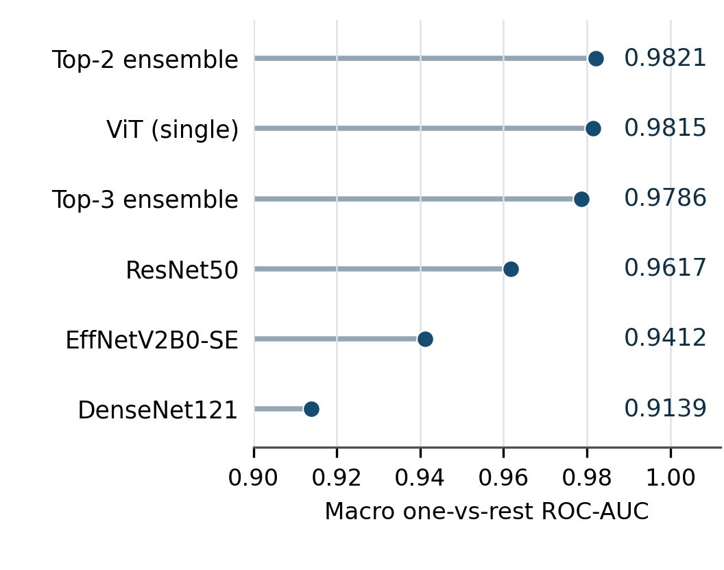
Fig. 3. Recorded macro one-vs-rest ROC-AUC scores (not full ROC curves).

Validation-Ranked Soft-Voting Ensembles
Equal-weight soft voting combined complementary validation-ranked models [20]. Both ensembles achieved 86.09% test accuracy (Table VI). Top-3 (ViT, ResNet50, EfficientNetV2B0-SE) yielded the highest macro-F1 (0.8495) and balanced accuracy (0.8623), whereas Top-2 retained the highest macro ROC-AUC (0.9821). Thus, the third member improved class balance more than discrimination. Fig. 4 compares accuracy and macro-F1.
TABLE VI
SOFT-VOTING ENSEMBLE RESULTS
Ensemble | Accuracy | F1 | Bal. acc. | AUC | Val. F1
Top-2 (ViT+ResNet50) | .8609 | .8440 | .8453 | .9821 | .8857
Top-3 (+EffNet-SE) | .8609 | .8495 | .8623 | .9786 | .8890
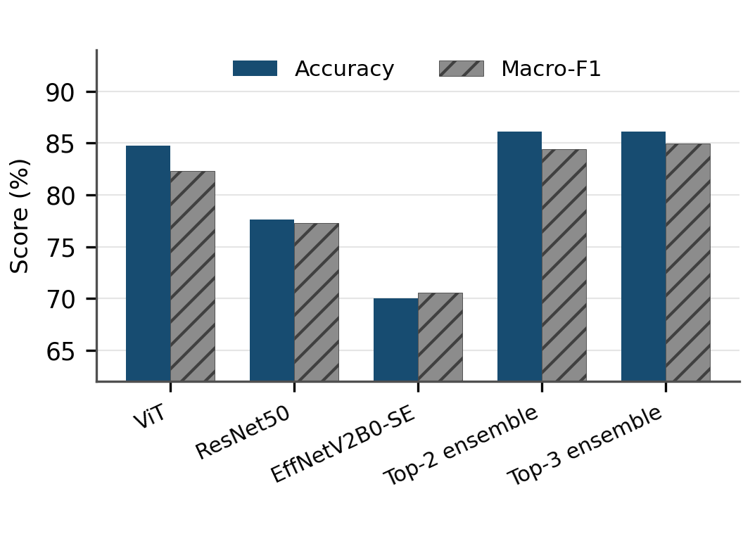
Fig. 4. Accuracy and macro-F1 for selected models and ensembles.

CNN Ablation Analysis
Table VII isolates squeeze-and-excitation (SE) attention [18] and focal loss [19]. The class-weighted baseline scored 65.29% macro-F1, improving to 70.55% with SE alone and 68.60% with focal loss alone. Combining SE and focal loss gave 65.08%, showing that the two components were not complementary in this setting. The Top-3 ensemble therefore used the SE-only variant.
TABLE VII
EFFICIENTNETV2B0 COMPONENT ABLATIONS
Variant | SE | Focal | Acc. (%) | F1 (%)
A: weighted CE | No | No | 64.57 | 65.29
B: A + SE | Yes | No | 70.00 | 70.55
C: focal loss | No | Yes | 69.13 | 68.60
D: SE + focal | Yes | Yes | 63.70 | 65.08
Plain CE control | No | No | 69.78 | 68.10
CE = cross-entropy. Variant A uses class-weighted CE; F1 denotes macro-F1. Test-set percentages are shown.

Class-Wise Errors and Explainability
The Top-3 confusion matrix (Fig. 5) contains 396 correct predictions among 460 test images. Class-wise true positives were Bacteria 84/85, Fungi 93/111, Healthy 24/27, Nematode 9/11, Pest 71/94, Phytopthora 47/53, and Virus 68/79. Fungi–Pest errors remained important. Fig. 6 shows notebook-derived Grad-CAM [21] examples for CNNs. Activations extending beyond the leaf suggest feature sensitivity, not causal lesion localization. No ViT attribution map was available.
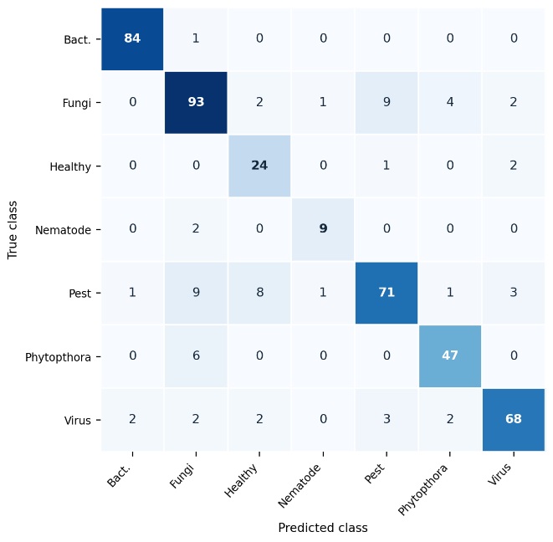

Fig. 5. Held-out confusion matrix for the Top-3 ensemble.
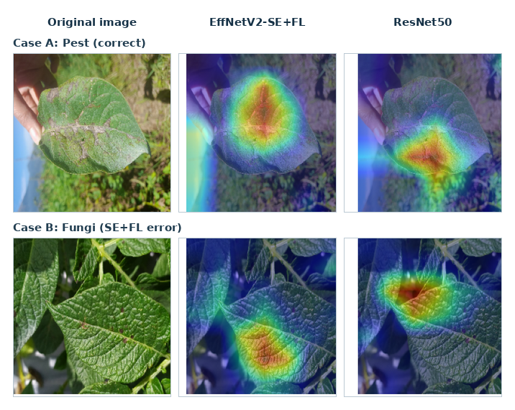
Fig. 6. Original notebook Grad-CAM examples for CNN architectures.

Training Dynamics and Reliability
Fig. 7 shows ViT validation macro-F1 increasing after fine-tuning began at epoch 6, reaching 0.8674 at epoch 23. This supports validation-based checkpoint selection.

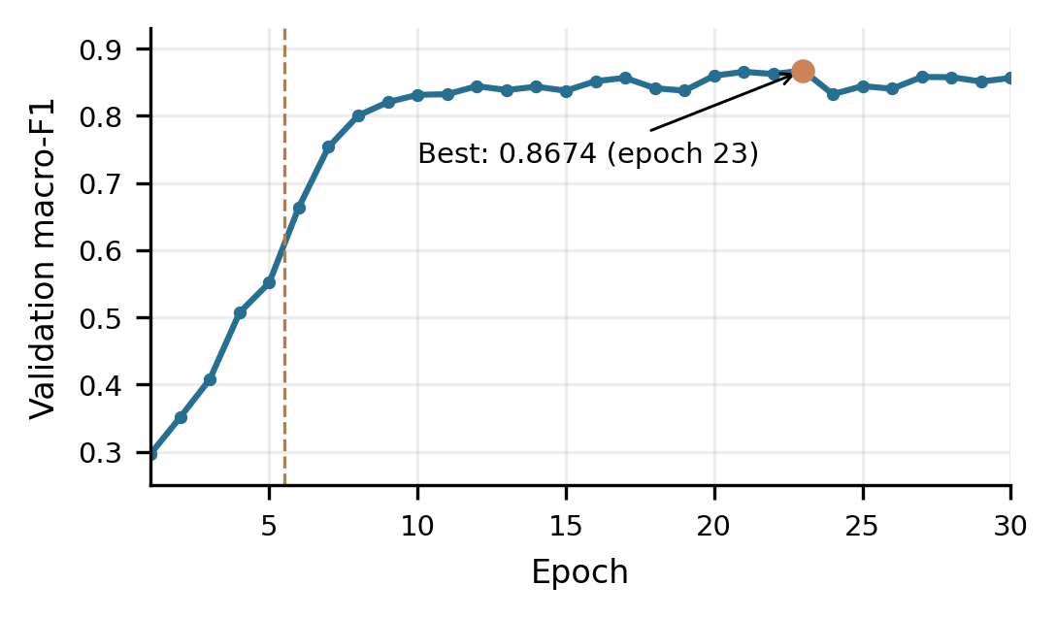
Fig. 7. ViT validation macro-F1 over 30 epochs.
For Top-2 versus ViT, 2,000 stratified bootstrap replicates [21] yielded an accuracy difference of +0.0130 (95% CI: −0.0043 to 0.0304) and macro-F1 difference of +0.0212 (95% CI: −0.0135 to 0.0597). Both intervals contained zero; McNemar’s exact test [22] gave p = 0.2632. Therefore, the improvement was numerical but statistically inconclusive. Further independent field validation is needed.

CONCLUSION
This study developed and evaluated a seven-class potato leaf disease classification framework using convolutional neural networks (CNNs), a Vision Transformer (ViT), and heterogeneous soft-voting ensembles. A duplicate-aware, group-based split was applied to 3,076 images to reduce data leakage. Among individual models, the partially fine-tuned ViT achieved 84.78% accuracy and 82.28% macro-F1. The Top-3 ensemble of ViT, ResNet50, and EfficientNetV2B0-SE attained 86.09% accuracy, 84.95% macro-F1, and 86.23% balanced accuracy on 460 held-out test images.
Ablation experiments showed that squeeze-and-excitation attention improved EfficientNetV2B0, whereas combining attention with focal loss did not yield further gains. Confusion matrices revealed persistent errors between visually similar disease categories, while Grad-CAM provided qualitative insight into CNN predictions. Although ensemble results were numerically stronger, statistical testing did not establish a significant improvement of the Top-2 ensemble over ViT alone. These findings highlight the value of validation-based model selection and complementary representations rather than architectural complexity alone. Future work should assess larger, more diverse field datasets, strengthen minority-class recognition, investigate computational efficiency, and perform independent external validation under variable lighting, backgrounds, and disease severity conditions before real-world agricultural deployment.

References
- S. P. Mohanty, D. P. Hughes, and M. Salathé, “Using deep learning for image-based plant disease detection,” Frontiers in Plant Science, vol. 7, Art. no. 1419, 2016, doi: 10.3389/fpls.2016.01419.
- J. G. A. Barbedo, “Factors influencing the use of deep learning for plant disease recognition,” Biosystems Engineering, vol. 172, pp. 84–91, 2018, doi: 10.1016/j.biosystemseng.2018.05.013.
- E. C. Too, L. Yujian, S. Njuki, and L. Yingchun, “A comparative study of fine-tuning deep learning models for plant disease identification,” Computers and Electronics in Agriculture, vol. 161, pp. 272–279, 2019, doi: 10.1016/j.compag.2018.03.032.
- M. Tan and Q. Le, “EfficientNetV2: Smaller models and faster training,” in Proc. 38th Int. Conf. Machine Learning (ICML), ser. Proceedings of Machine Learning Research, vol. 139, 2021, pp. 10096–10106. [Online]. Available: https://proceedings.mlr.press/v139/tan21a.html
- A. Dosovitskiy et al., “An image is worth 16x16 words: Transformers for image recognition at scale,” in Proc. Int. Conf. Learning Representations (ICLR), 2021. [Online]. Available: https://openreview.net/forum?id=YicbFdNTTy
- Q. Meng, J. Guo, H. Zhang, Y. Zhou, and X. Zhang, “A dual-branch model combining convolution and vision transformer for crop disease classification,” PLOS ONE, vol. 20, no. 4, Art. no. e0321753, 2025, doi: 10.1371/journal.pone.0321753.
- T.-Y. Lin, P. Goyal, R. Girshick, K. He, and P. Dollár, “Focal loss for dense object detection,” in Proc. IEEE Int. Conf. Computer Vision (ICCV), 2017, pp. 2980–2988, doi: 10.1109/ICCV.2017.324.
- N. H. Shabrina et al., “A novel dataset of potato leaf disease in uncontrolled environment,” Data in Brief, vol. 52, Art. no. 109955, 2024, doi: 10.1016/j.dib.2023.109955.
- G. Boukhlifa and Y. Chibani, “DSCSkipNet: An accuracy-complexity trade-off for effective potato disease identification in uncontrolled environments,” in Proc. 4th Int. Conf. Embedded and Distributed Systems (EDiS), 2024, pp. 267–272, doi: 10.1109/EDiS63605.2024.10783376.
- P. Mhala, A. Bilandani, and S. Sharma, “Enhancing crop productivity with fined-tuned deep convolution neural network for potato leaf disease detection,” Expert Systems with Applications, vol. 267, Art. no. 126066, 2025, doi: 10.1016/j.eswa.2024.126066.
- M. H. Tariq et al., “Estimation of fractal dimensions and classification of plant disease with complex backgrounds,” Fractal and Fractional, vol. 9, no. 5, Art. no. 315, 2025, doi: 10.3390/fractalfract9050315.
- J. H. Sinamenye, A. Chatterjee, and R. Shrestha, “Potato plant disease detection: Leveraging hybrid deep learning models,” BMC Plant Biology, vol. 25, Art. no. 647, 2025, doi: 10.1186/s12870-025-06679-4.
- A. Elkholy, N. M. Elshennawy, and A. M. Gab Allah, “AI-driven agricultural productivity: Detecting potato leaf diseases with multi-scale feature extraction,” Journal of King Saud University—Computer and Information Sciences, vol. 38, Art. no. 721, 2026, doi: 10.1007/s44443-026-01123-5.
- warcoder, “Potato leaf disease dataset,” Kaggle. [Online]. Available: https://www.kaggle.com/datasets/warcoder/potato-leaf-disease-dataset
- G. Huang, Z. Liu, L. van der Maaten, and K. Q. Weinberger, “Densely connected convolutional networks,” in Proc. IEEE Conf. Computer Vision and Pattern Recognition (CVPR), 2017, pp. 2261–2269, doi: 10.1109/CVPR.2017.243.
- K. He, X. Zhang, S. Ren, and J. Sun, “Deep residual learning for image recognition,” in Proc. IEEE Conf. Computer Vision and Pattern Recognition (CVPR), 2016, pp. 770–778, doi: 10.1109/CVPR.2016.90.
- J. Hu, L. Shen, and G. Sun, “Squeeze-and-excitation networks,” in Proc. IEEE Conf. Computer Vision and Pattern Recognition (CVPR), 2018, pp. 7132–7141, doi: 10.1109/CVPR.2018.00745.
- R. R. Selvaraju et al., “Grad-CAM: Visual explanations from deep networks via gradient-based localization,” in Proc. IEEE Int. Conf. Computer Vision (ICCV), 2017, pp. 618–626, doi: 10.1109/ICCV.2017.74.
- T. Fawcett, “An introduction to ROC analysis,” Pattern Recognition Letters, vol. 27, no. 8, pp. 861–874, 2006, doi: 10.1016/j.patrec.2005.10.010.
- T. G. Dietterich, “Ensemble methods in machine learning,” in Multiple Classifier Systems, Lecture Notes in Computer Science, vol. 1857. Berlin, Germany: Springer, 2000, pp. 1–15, doi: 10.1007/3-540-45014-9_1.
- B. Efron and R. J. Tibshirani, An Introduction to the Bootstrap. New York, NY, USA: Springer, 1993, doi: 10.1007/978-1-4899-4541-9.
- Q. McNemar, “Note on the sampling error of the difference between correlated proportions or percentages,” Psychometrika, vol. 12, no. 2, pp. 153–157, 1947, doi: 10.1007/BF02295996.

